**SENIOR OPERATOR**

**SUPPLEMENTAL QUESTIONS**

**August 2024**

**Instructions for Supplemental Questions:**

Please be sure to answer the supplemental questions thoroughly and accurately. Applicants are responsible for clearly, completely, and accurately identifying their qualifications. Your responses to the questions must be supported by both the work experience listed on your application as well as your resume. The rating of the supplemental questions may determine your application status and/or rank on the eligible list. Responses should be sufficiently detailed to assist in evaluating your qualifications for this position. Writing 'see resume' or 'N/A' is not a sufficient response (unless indicated).

Type a thorough response to each of the following questions. Specify what you would do as well as the reasons behind your actions.

**Questions 1-5:**

1. Describe any experience and/or training which demonstrates your competency to participate on a Process Control Team for a conventional activated sludge treatment plant.
2. You observe a contractor working for SVCW drinking alcohol in the parking lot before work. Please describe how you would handle this situation.

3. SVCW promotes a Strong Safety Culture:

* 1. Please describe what a “Strong Safety Culture” means to you.
  2. Please describe your current employer’s safety culture.
  3. Please describe one safety item in your current job that you would change if given the opportunity.

4. You are a Senior (Journeyman) Operator working a Swing Shift (1:00pm to 11:00pm) and an Operation’s Supervisor calls you at 9:00pm directing you to make a process control change that you do not agree with. Describe how you will respond to the Supervisor.

5. As a Senior Operator, you notice the thickened sludge flow from Thickened Sludge Pump #3 is very low. The next page has photos of Thickened Sludge Pump #3 with labels on the equipment associated with the pump. Please tell us in detail how you would go about safely troubleshooting the low flow issue in this progressive cavity positive displacement pump.

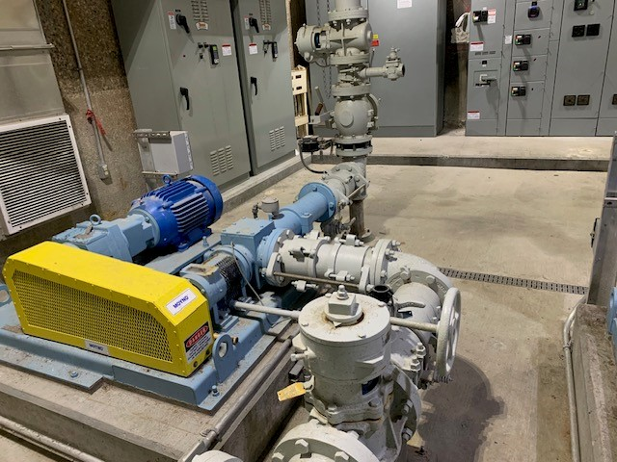

**Suction Valve**

**Discharge Valve**

**Check Valve** Valve

**Inspection Plate**

**Suction Pressure Relief**

**Discharge Pressure Relief**

**Pump #3 Main Power Breaker**

**Thickened Sludge Pump #3**

**Discharge Valve**

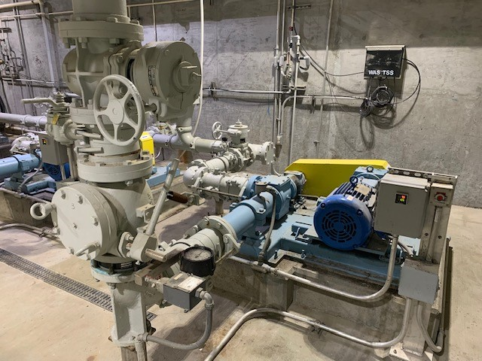

**Local Power Switch**

**Suction Valve**

**Check Valve** Valve

**Inspection Plate**

**Thickened Sludge Pump #3**