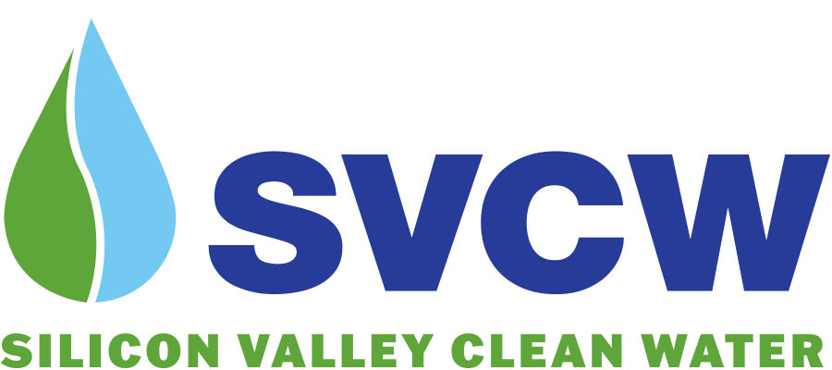

COMMISSION OF SILICON VALLEY CLEAN WATER

JOINT POWERS AUTHORITY

REGULAR MEETING – Thursday, December 11, 2025

8:00 a.m.

Place: Silicon Valley Clean Water

1400 Radio Road

Redwood City, California

Consistent with Government Code Section 54953, this meeting will be held both in person and virtually. See page 5 of this agenda for virtual meeting access information and instructions.

COMMISSIONERS:
Board Member George Otte, West Bay Sanitary District – Chair
Mayor Elmer Martínez Saballos, Redwood City – Vice Chair
Council Member Tom McCune, Belmont – Secretary
Council Member Neil Layton, San Carlos

AUTHORITY MANAGER:
Matthew Zucca, PE

AUTHORITY ATTORNEY:
Christine C. Fitzgerald

CONTROLLER:
Beth Goldberg (Redwood City)

TREASURER:
Matthew Anderson

Americans with Disabilities Act
In compliance with the Americans with Disabilities Act, if you need special assistance to participate in this meeting, please contact SVCW (650) 591-7121. Notification in advance of the meeting will enable the Authority to make reasonable arrangements to ensure accessibility to this meeting.

AGENDA
- CALL TO ORDER
- ROLL CALL
- PLEDGE OF ALLEGIANCE
- PUBLIC COMMENT
Any member of the public may address and ask questions of the Chair under this item relating to any matter within the Commission’s jurisdiction that does not appear as a separate item on the agenda. Opportunity will be provided for members of the public to address the Chair and ask questions about any item that is listed on the agenda at the time the Commission considers the item and before action is taken. If you address the Commission on a non-agenda item, be aware that the Ralph M. Brown Act (Gov. C. § 54950 et seq.) prohibits the Commission from acting on or discussing such matters at this meeting. Such item may be referred to staff for a decision with regard to placing it on a future agenda for discussion, action, or report.
- CONSIDERATION OF MOTION APPROVING CONSENT CALENDAR
NOTICE TO PUBLIC - All matters listed under CONSENT CALENDAR are considered to be routine. There may be discussion on items on the CONSENT CALENDAR. All items will be enacted by one motion with a voice vote unless members of the Commission, staff, or public request specific items be removed from the CONSENT CALENDAR for separate action.
  - APPROVAL OF MINUTES – November 2025 - Regular Meeting pg. 6
  - CLAIMS AND CHECKS DATED SEPTEMBER 30 - NOVEMBER 10, 2025, AND NECESSARY PAYMENTS THROUGH NOVEMBER 10, 2025 pg. 9
  - RESOLUTION NO. SVCW 25-37 RATIFYING CONTRACTS APPROVED BY THE AUTHORITY MANAGER PURSUANT TO AUTHORITY DELEGATED UNDER RESOLUTION NO. SVCW 25-15 pg. 22
- BUSINESS ITEMS
  - Status update on recycled water and potable reuse initiatives, including the PureWater Peninsula Project. pg. 27
Proposed Action: None – Information Only
  - Award construction contract and approve task orders for engineering services during construction for the Aeration Basin and Dual Media Filter Influent Piping Rehabilitation Project (CIP#9600) pg. 69

Proposed Actions:
- Move adoption of RESOLUTION NO. SVCW 25-38 APPROVING CONSTRUCTION CONTRACT DOCUMENTS FOR THE AERATION BASIN AND DUAL MEDIA FILTER INFLUENT PIPING REHABILITATION PROJECT (CIP#9600); ACCEPTING BID OF LOWEST RESPONSIBLE BIDDER; AUTHORIZING EXECUTION OF AGREEMENT AND DIRECTING RETURN OF SECURITY DEPOSITS AND AUTHORIZING MANAGER TO APPROVE CONTRACT CHANGE ORDERS UP TO TEN PERCENT OF THE CONTRACT PRICE FOR SAID PROJECT ($6,572,400) – J.F. Shea Construction Inc.

2. Move approval of TASK ORDER SCOPE OF WORK AND BUDGET FOR ENGINEERING SERVICES DURING CONSTRUCTION FOR THE AERATION BASIN AND DUAL MEDIA FILTER INFLUENT PIPING REHABILITATION PROJECT (CIP#9600) IN AN AMOUNT NOT TO EXCEED $655,000 AND AUTHORIZE MANAGER TO APPROVE UP TO TEN PERCENT CONTINGENCY FOR ADDITIONAL WORK ON AN AS-NEEDED BASIS – Brown and Caldwell
  - Task order for Brown and Caldwell to perform a Plant Capacity Analysis and Connection Fee Study pg. 95
Proposed Action: Move approval of TASK ORDER SCOPE AND BUDGET FOR CAPACITY ANALYSIS REPORT IN AN AMOUNT OF $215,630 AND AUTHORIZE MANAGER TO APPROVE UP TO TEN PERCENT CONTINGENCY FOR ADDITIONAL WORK ON AN AS-NEEDED BASIS FOR A TOTAL AUTHORIZED AMOUNT OF $237,193.00 (BROWN AND CALDWELL)
  - Adding Operator-In-Training (OIT) job description and approving an Updated Consolidated Pay Schedule pg. 106
Proposed Actions:
- Move adoption of RESOLUTION NO. SVCW 25-39 AMENDING SECTION 6 OF RESOLUTION NO. SVCW 77-6, THE SVCW PERSONNEL RESOLUTION, RELATING TO CLASSIFICATION OF POSITIONS AND RESCINDING PARAGRAPH 1 OF RESOLUTION NO. SVCW 25-21 AND ANY AND ALL OTHER RESOLUTIONS OR PROVISIONS THEREOF IN CONFLICT HEREWITH
- Move adoption of RESOLUTION NO. SVCW 25-40 MOVING AND ADOPTING CONSOLIDATED PAY SCHEDULE FOR ALL REPRESENTED AND UNREPRESENTED EMPLOYEES OF SILICON VALLEY CLEAN WATER FOR FISCAL YEAR 2025-2026
- REPORTS
  - Manager’s Report pg. 123
  - Financial Report
    - Investment Report October pg. 134
    - Quarterly Investment Portfolio pg. 137
    - Operating Fund Financial Update pg. 235
  - Engineering Capital Projects Report pg. 235
- MATTERS OF COMMISSION MEMBERS’ INTEREST
- COMMUNICATIONS
  - Press Release Celebrating Silicon Valley Clean Water’s 50th Anniversary (to be distributed at the Commission meeting)
- ADJOURN
Microsoft Teams Access Information
Silicon Valley Clean Water
Regular Meeting
Thursday, December 11, 2025

WEBSITE: Link to access meeting
MEETING ID: 270 547 566 14
CALL IN PHONE NUMBER: +1 747-216-0281 ID: 925 412 740#

You may log in via URL located on SVCW’s website at https://svcw.org/about/governance/commission-meetings. You may view video during the meeting via live stream. An audio will be available after the meeting at SVCW’s website. If you experience technical difficulties or have technical questions prior to or during the meeting, please contact Teams meeting support at 707-862-0859. Note: Public participation is not permitted during closed session discussion items.

Public Comment
Public comment may be made by joining the meeting using the link or phone number above. Members of the public may provide public comments via the Teams platform by using the “raise hand” feature or, if calling in by phone, by unmuting and beginning to speak. In response to a “raised hand”, SVCW will unmute the member of public and allow them to speak. In response to a phone request to speak, SVCW will ask what is the nature of the comment and will provide directions to follow to provide comment. Public comments will be limited to three minutes.

Public comment may also be made by emailing comments to commission@svcw.org up to two hours prior to the scheduled meeting time. Indicate in your email the agenda item to which your comment applies. If you have anything that you wish distributed to the Commission and included for the official record, please include it in your email.

Accessibility for Individuals with Disabilities
Upon request, SVCW will provide for access to individuals with disabilities to fully engage in the meeting process. Joining the meeting via the teleconference instructions above will provide access to open captioning. For other accommodations, please email your request to commission@svcw.org or call 650-591-7121 at least four (4) days prior to the scheduled meeting time. Requests will be granted whenever possible and resolved in favor of accessibility.

Subject to Change:
The format of this meeting may change or the meeting may be canceled. You may check on the status of the meeting by visiting SVCW’s website www.svcw.org.

